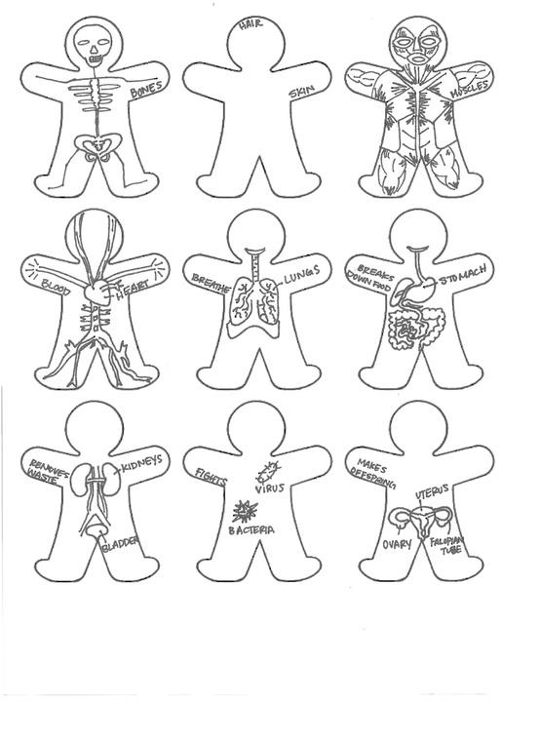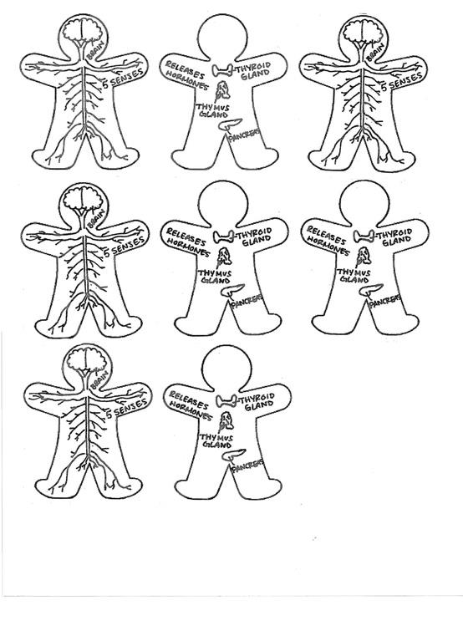

Glue Here

Skeletal System Muscular System Circulatory System Respiratory System Digestive System

Reproductive System Excretory System Immune System Endocrine System Nervous System

Color and label each body system, then cut out the strips and glue them together to create one, long, body-systems chain.

**You should be including these systems:**